

**Cloud Computing BSE-VB**

**Submitted By**

Tooba Shafique (2023-BSE-065)

**Submitted to**

Sir Shoaib

**LAB-02**

**Getting Started**

Install Git on your PC.

From google, download git for winndows

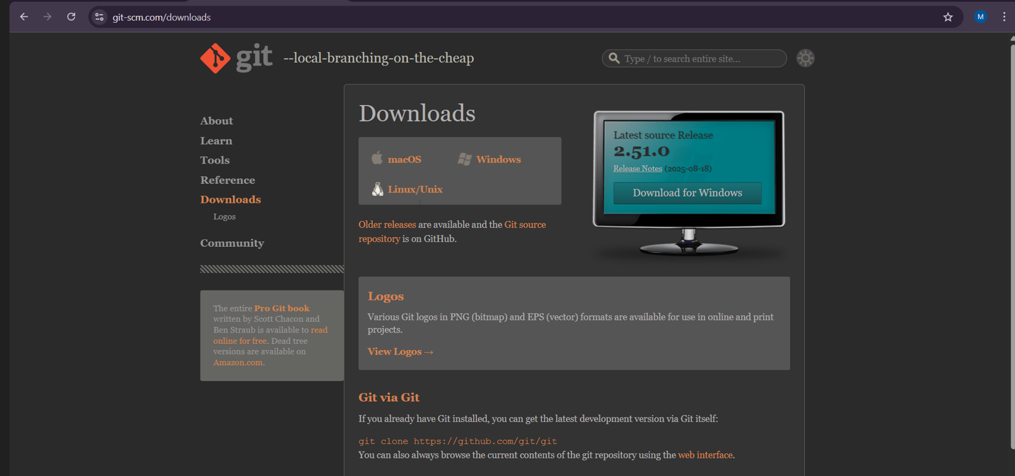

check the desired box and click on “next”

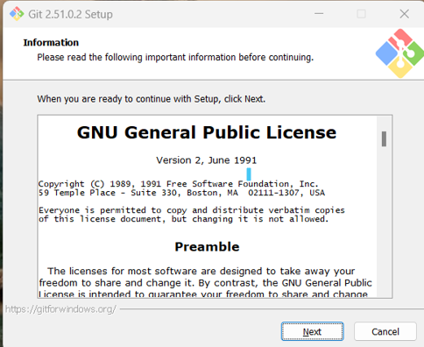

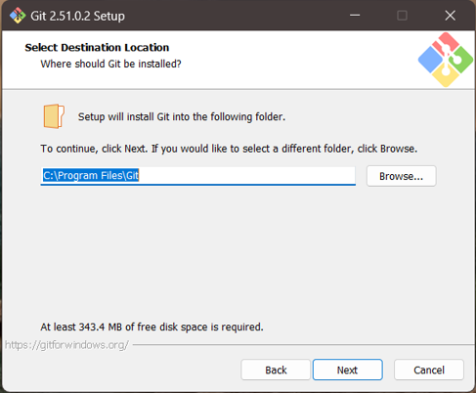

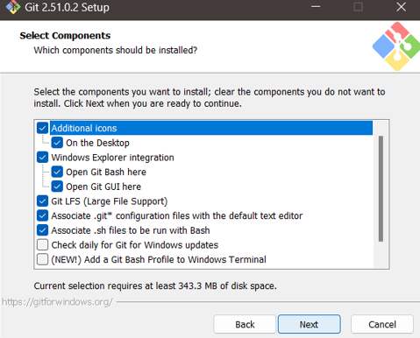 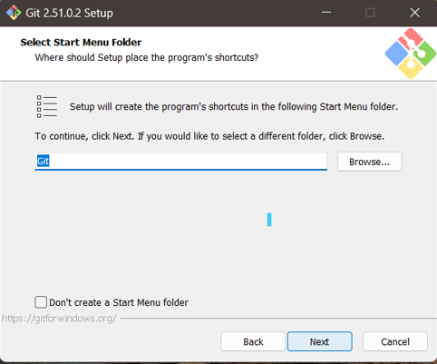 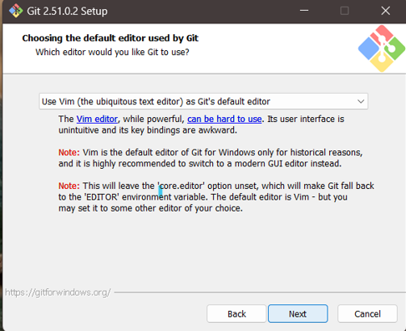 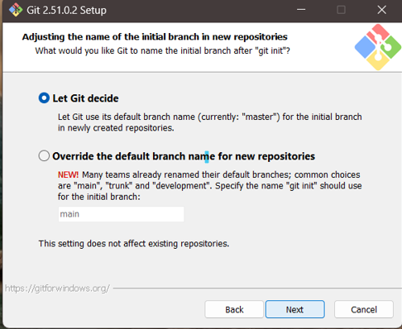 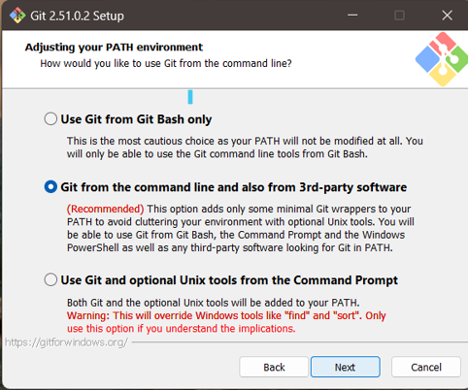 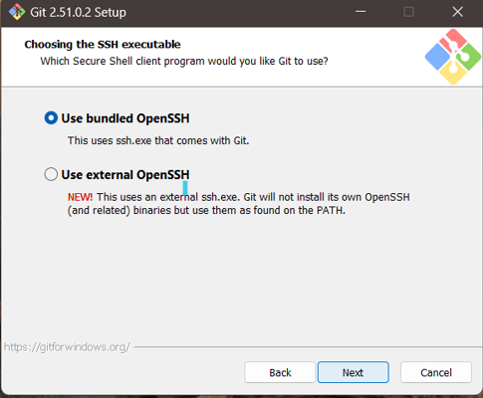 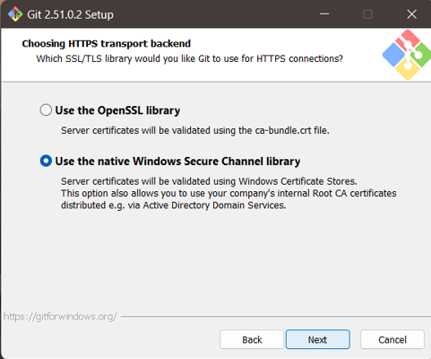 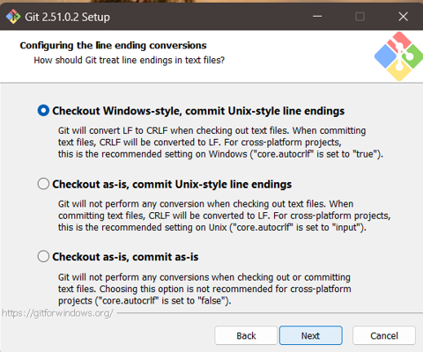 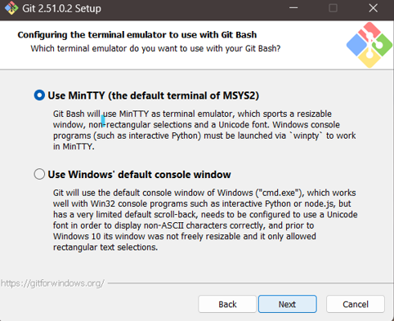 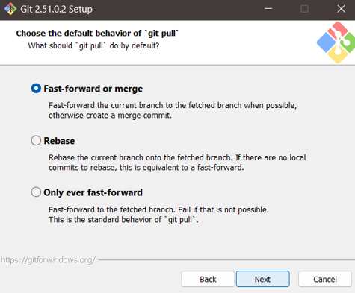 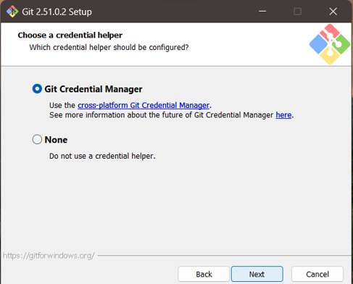 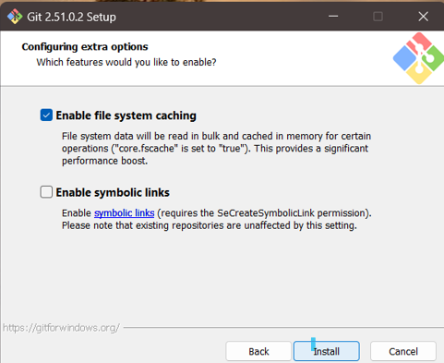

Installation Completed.

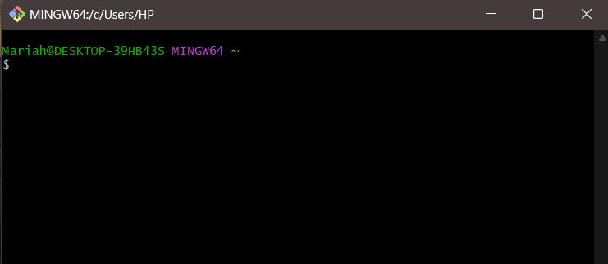

**TASK NO 01:**

Create Private GitHub Repository

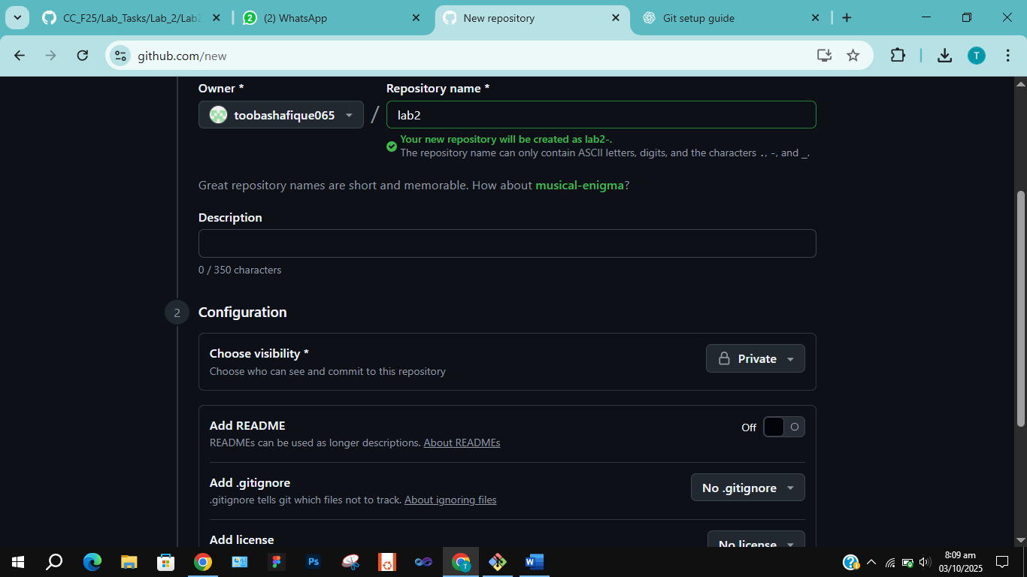

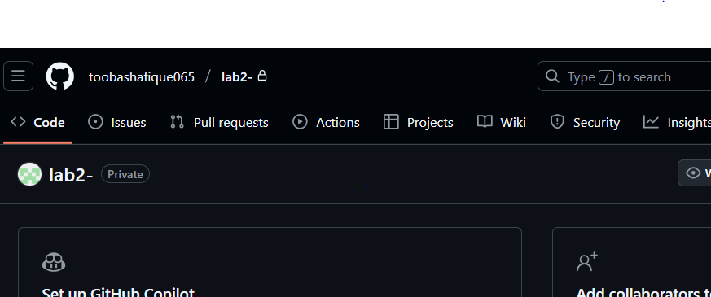

**TASK NO 02:**

Connect Repository via SSH

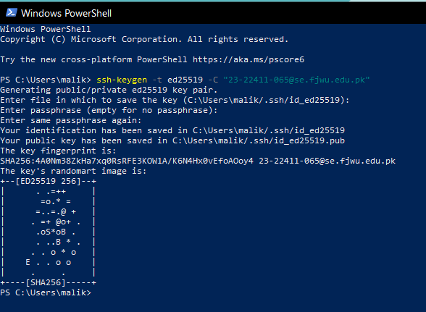

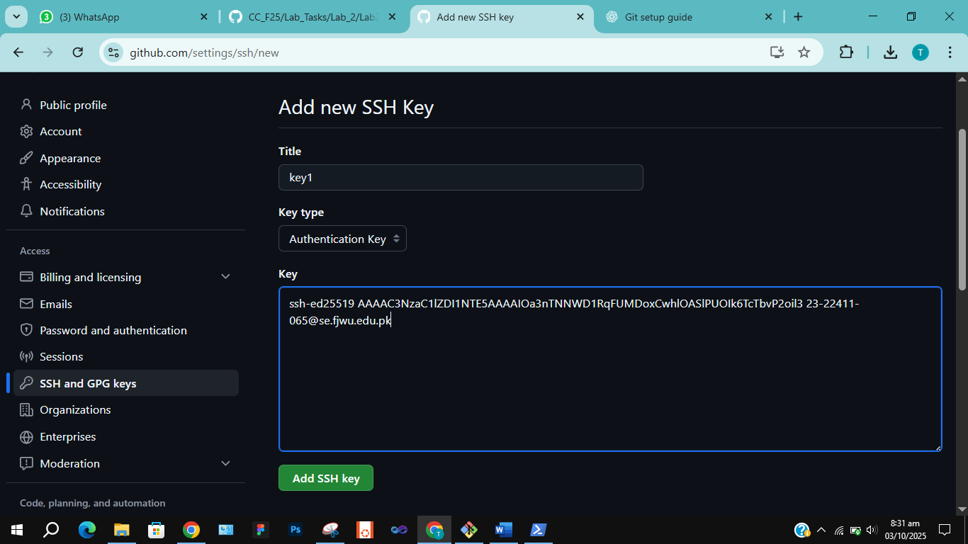

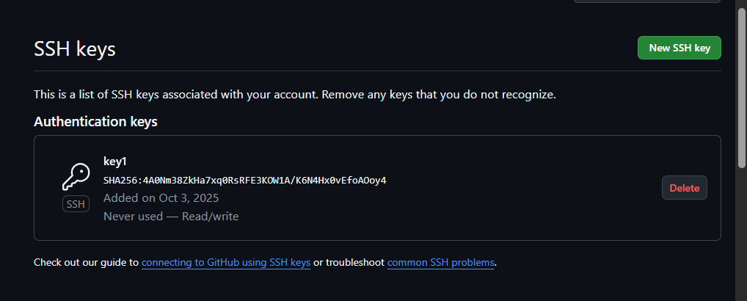

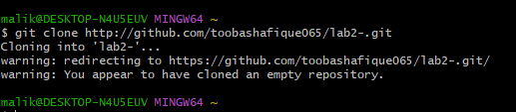

**TASK NO 03:**

Configure Git Username and Email

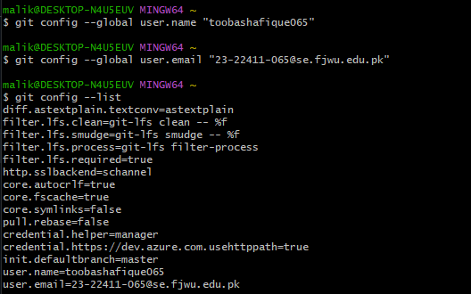

**TASK NO 04:**

Explore the .git Folder

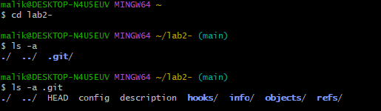

**TASK NO 05:**

Local Repository Management

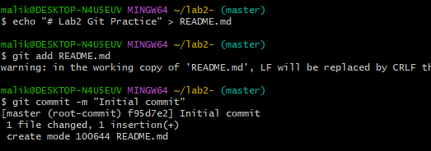

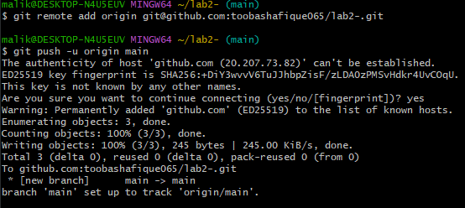

**TASK NO 06:**

File Status & Staging

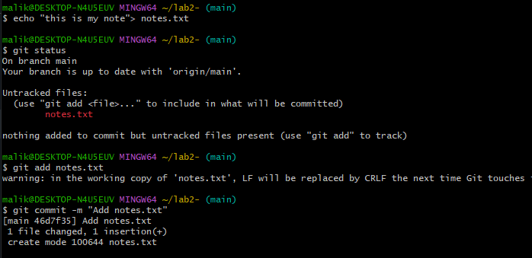

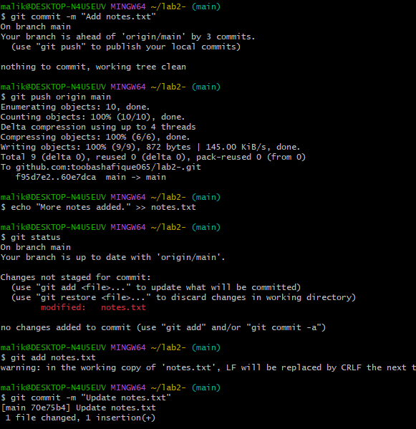

**Updated:**



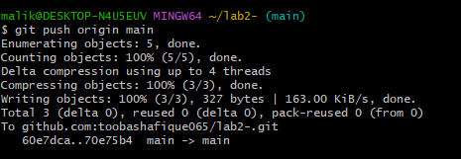

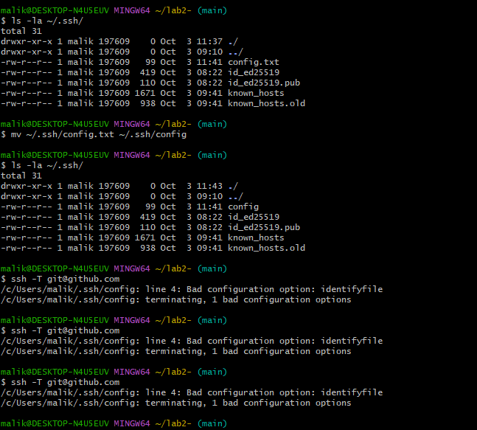

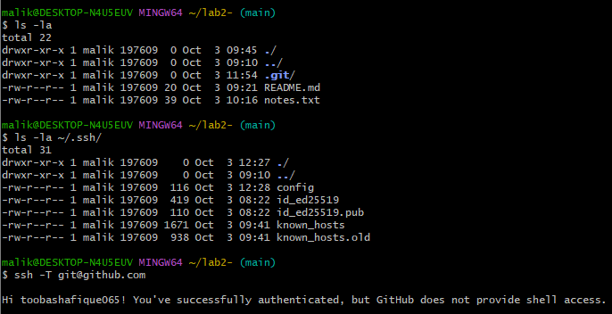

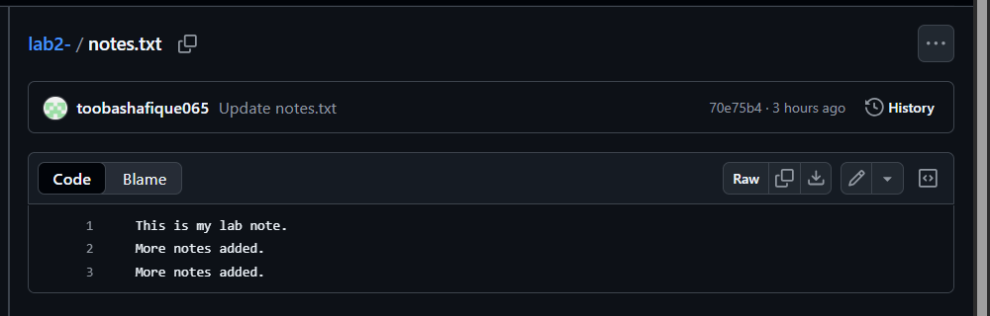

**TASK NO 07:**

Branch Creation Using GitHub GUI

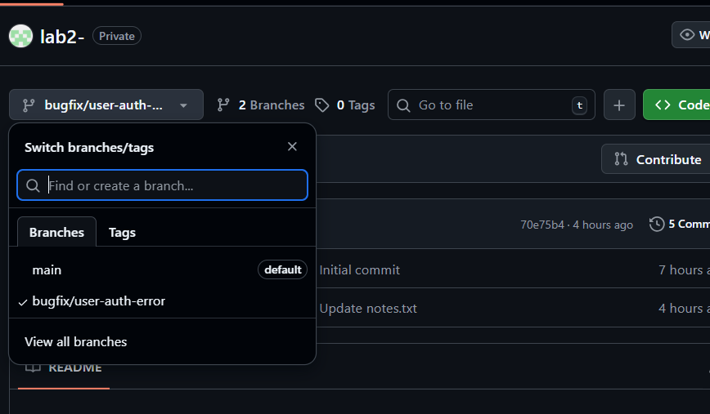

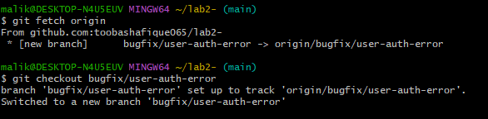

**TASK NO 08:**

 Branch Creation and Push Using Git Bash

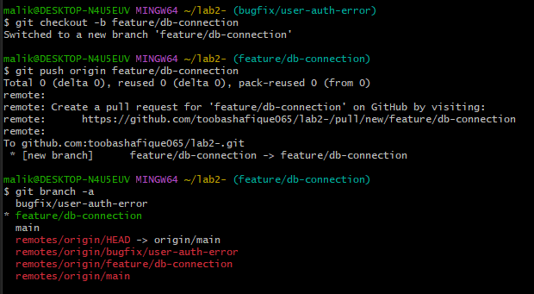

**TASK NO 09:**

Branching & Merging



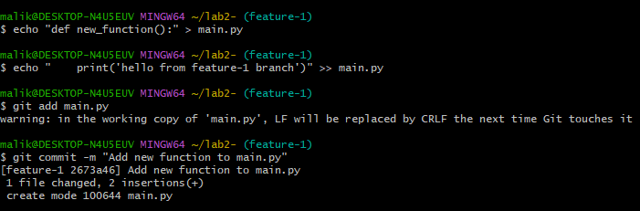

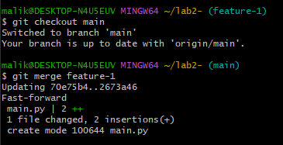

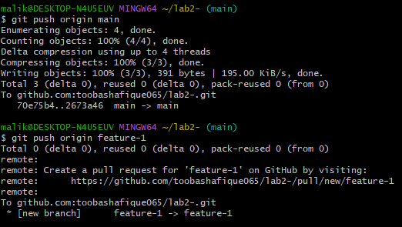

**TASK NO 10:**

I made changes in origin feature/db-connection to create pull request.

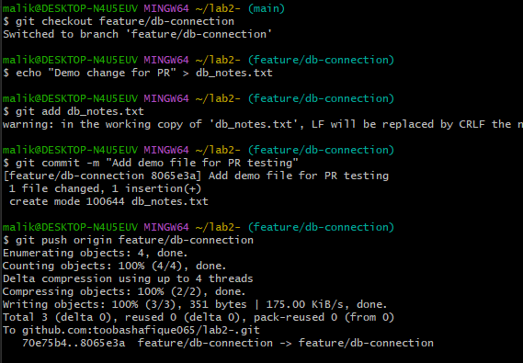

Pull Request and Branch Review (GitHub GUI)

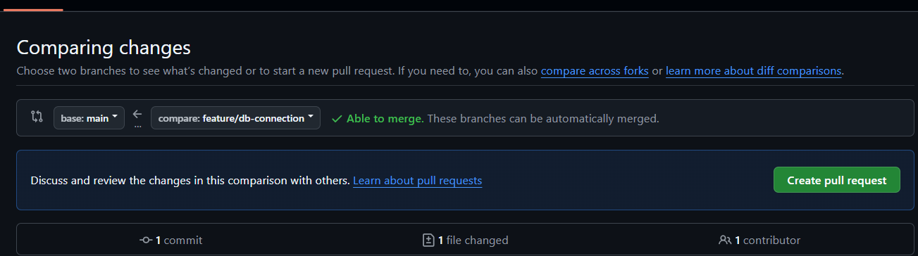

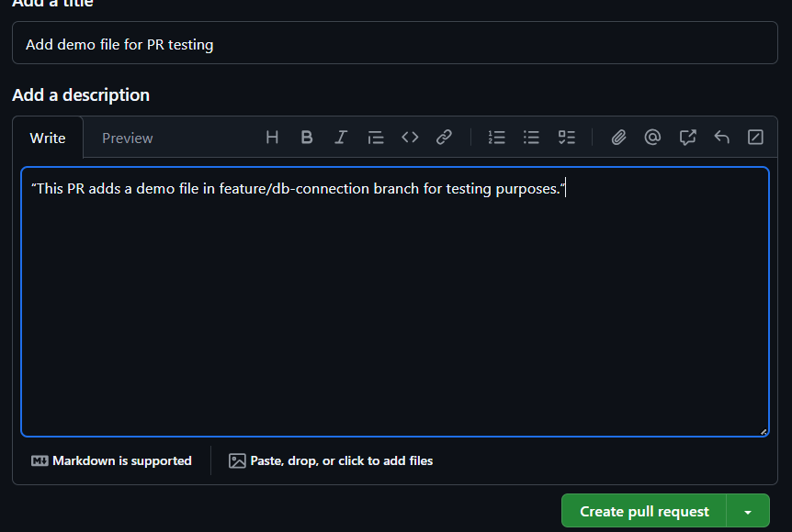

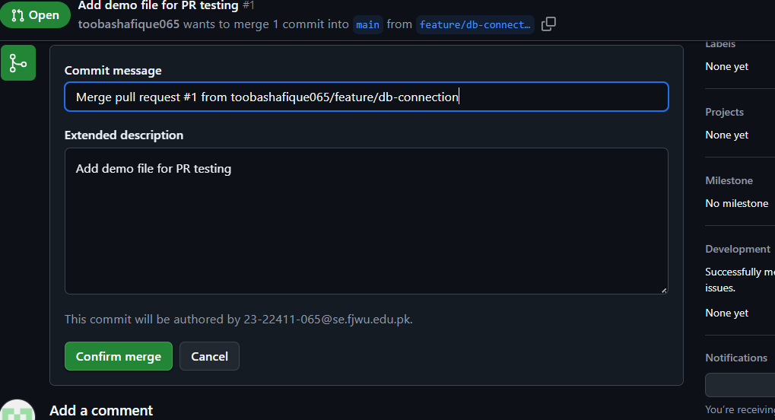

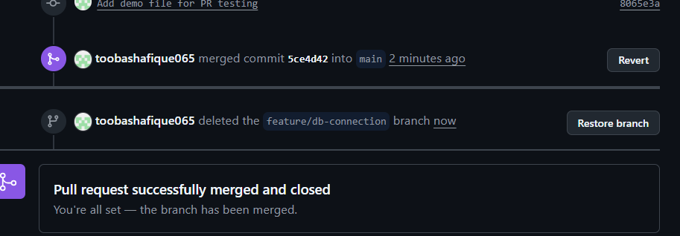

**TASK NO 11:**

Detailed Branch Strategy (Develop/Staging)

* Create long-lived branches develop and staging (and push them)

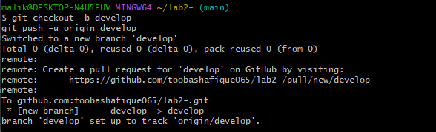

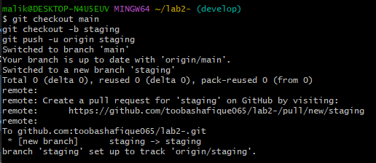

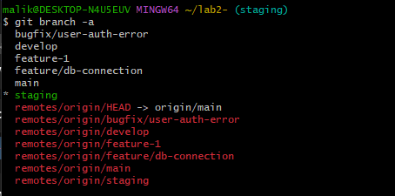

* Create example feature and bugfix branches (off develop) and push them

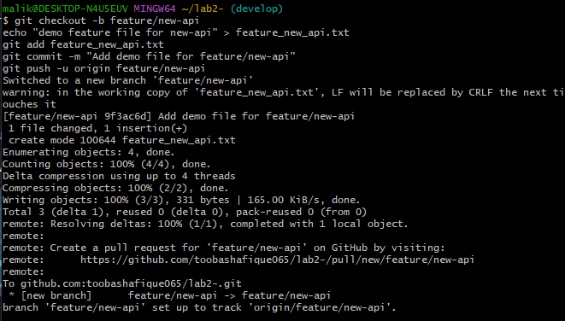

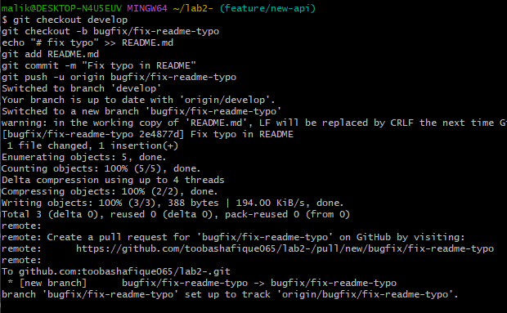

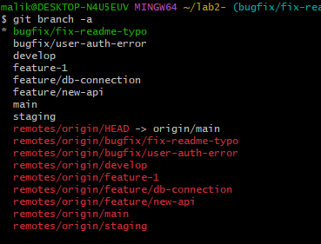

* Merge feature/bugfix into develop

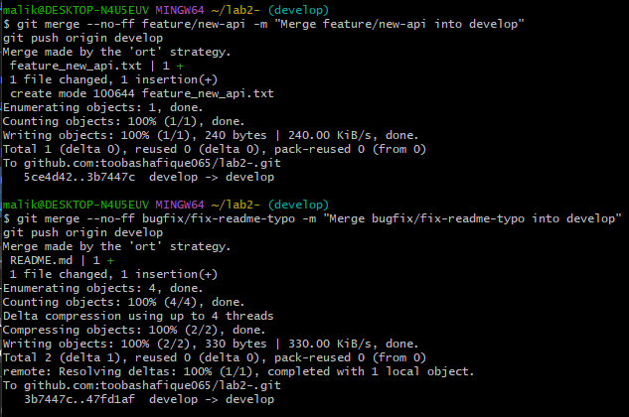

* Merge develop into staging (testing

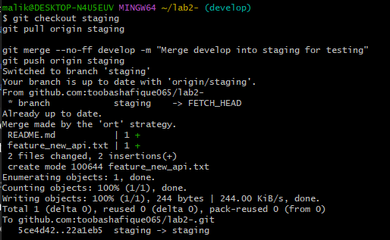

* Final: merge staging into main (production)

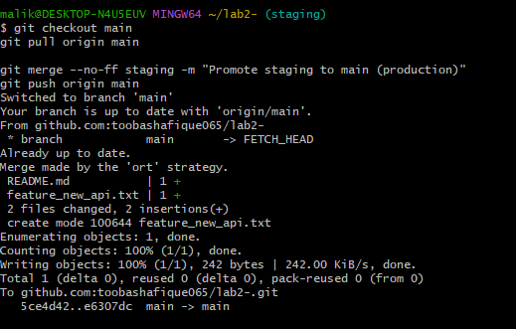

* Clean-up

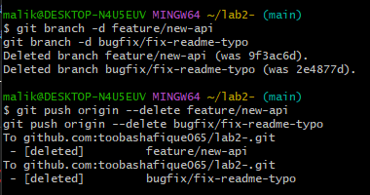

**Bonus Task:**

Simulated Team Collaboration

Step 1 — Create and switch to collab branch



Step 2 – (Add collaborator)

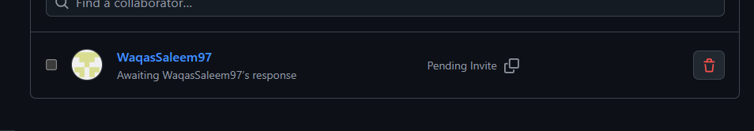

Step 3 – Simulate “both users” editing the file

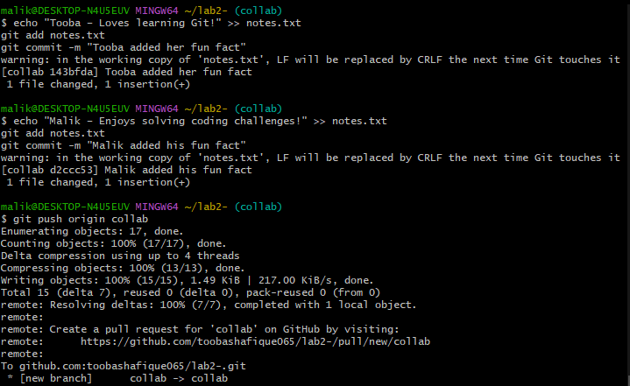

Step 4 – Merge collab → main

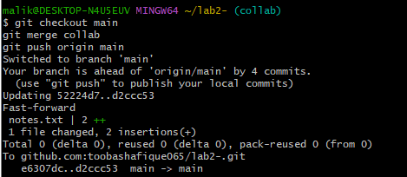

**TASK NO 12:**

Step 1 – Create a feature branch locally

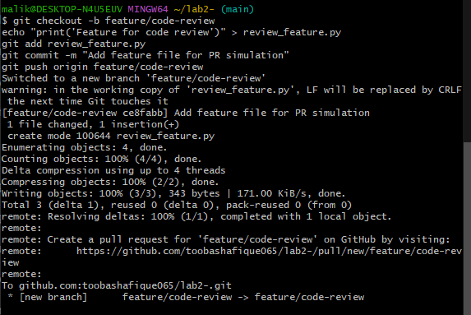

Step 2 – Create the Pull Request (GitHub UI)

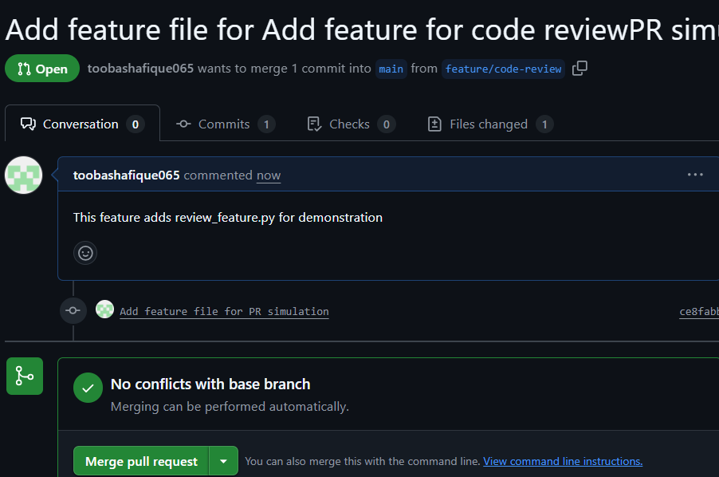

Step 3 – Assign a Reviewer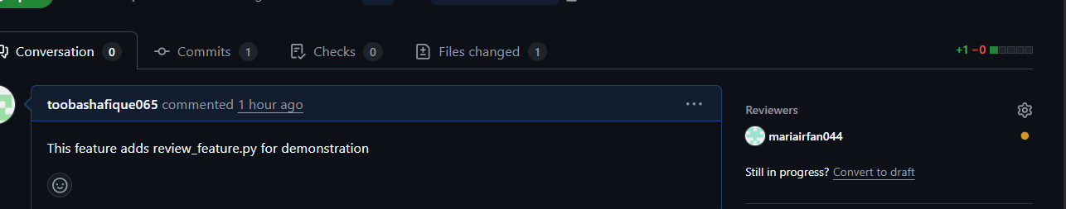

Step 4 – Reviewer Actions

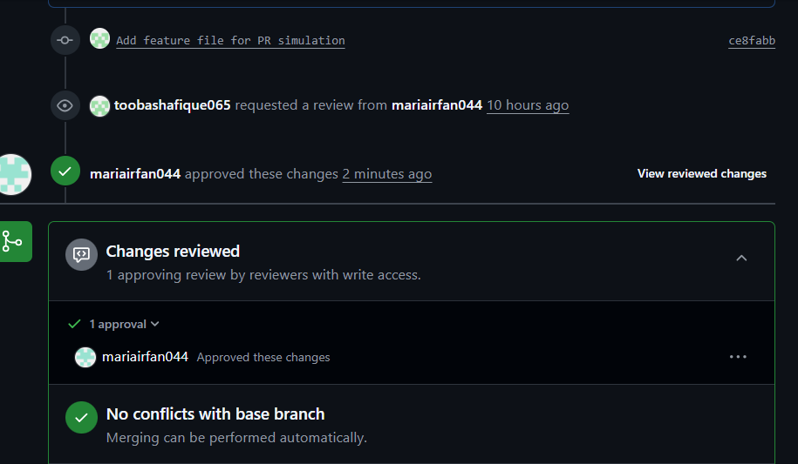

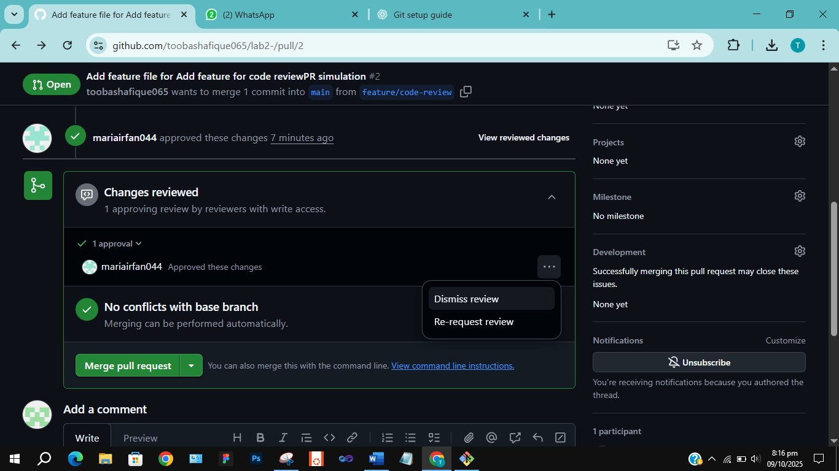

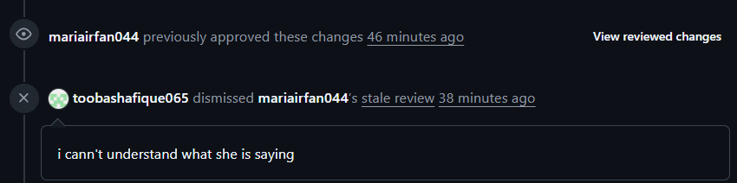

Step 5 – Author fixes issues

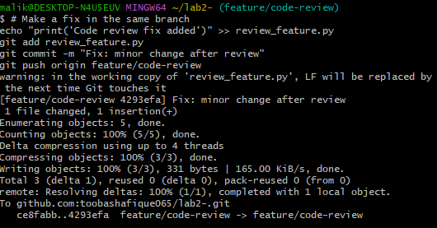

Step 6 – Merge PR

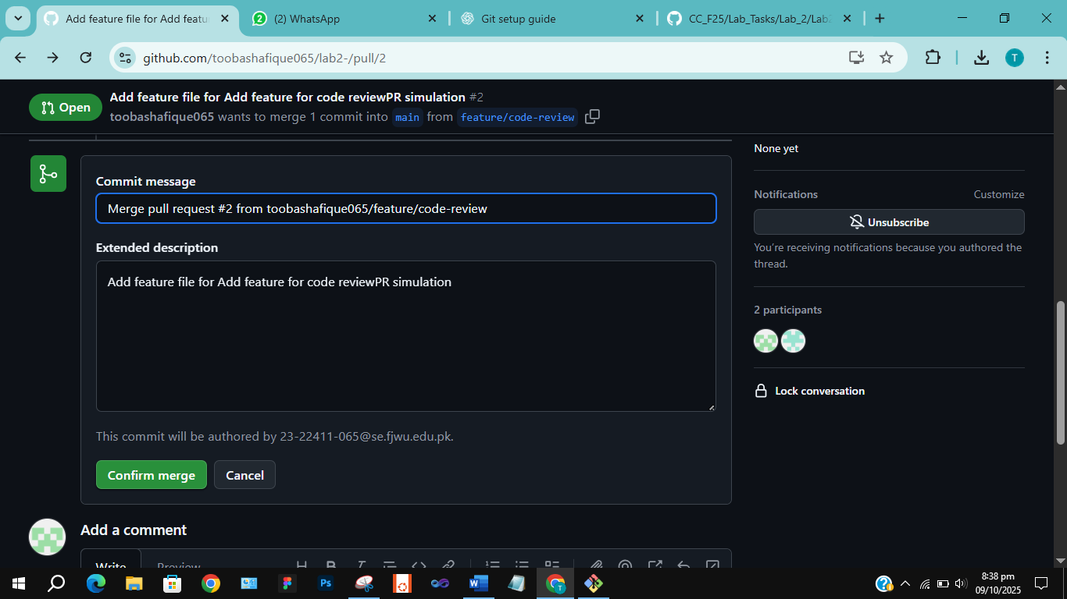

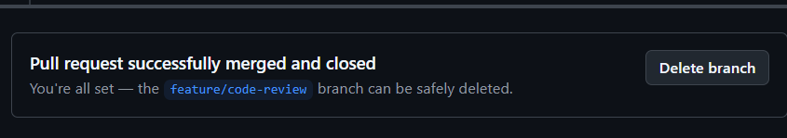

Step 7 – Branch handling after merge

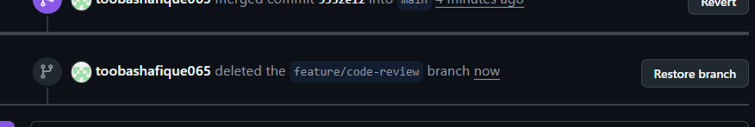

**TASK NO 13:**

Step 1 – Delete Remote Branch After Merg



Step 2 – Update Local Repository

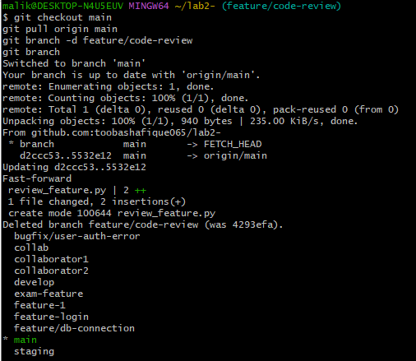

**Exam evaluation questions:**

**Q1: Advanced Branching & Merge Verification**

Step 1 — Create a new branch



Step 2 — Make a small change & commit

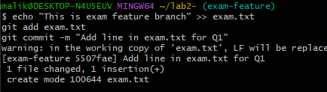

Step 3 — Merge into main

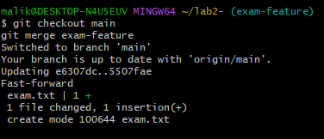

Step 4 — Show history verifying merge

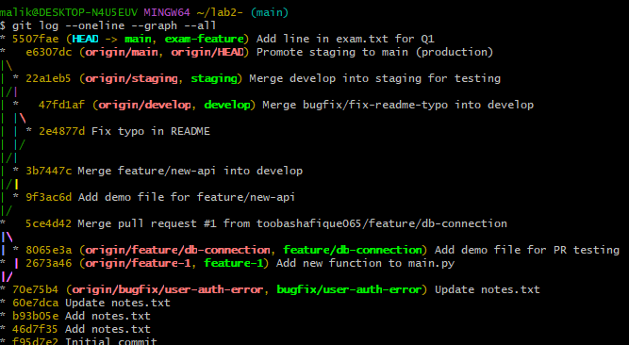

**Q2: Multi-Stage Workflow Simulation**

Step 1 — Switch to develop and create a new feature branch

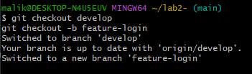

Step 2 — Add a small change and commit it

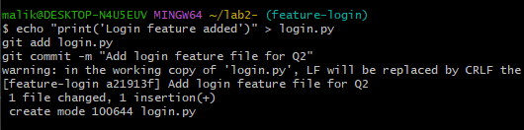

Step 3 — Merge feature-login → develop

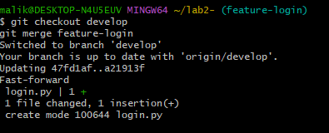

Step 4 — Merge develop → staging

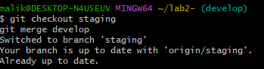

Step 5 — Merge staging → main

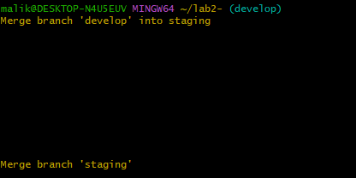

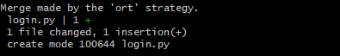

Step 6 — Verify the change reached all branches

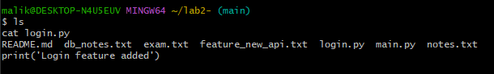

**Q3: Collaboration & Conflict Resolution**

* Step 1: Work with a collaborator (create separate branches and edits)

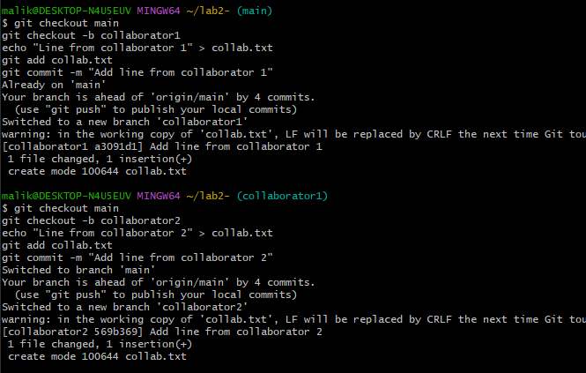

* Step 2: Attempt to Merge (create conflict)

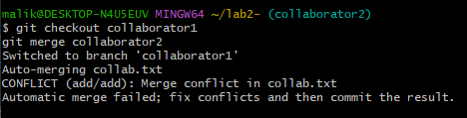

* Step 3: Resolve the Conflict (keep both contributors’ lines)

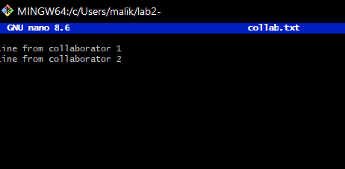

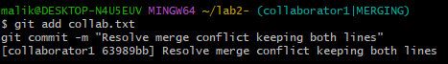

* Step 4: Verify final file (both lines preserved)

